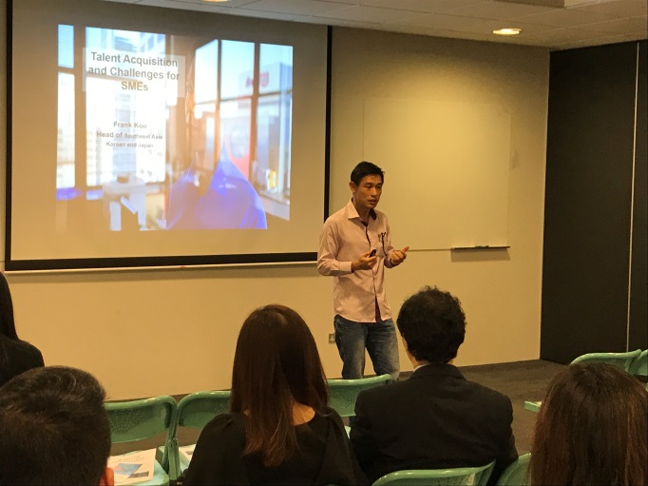
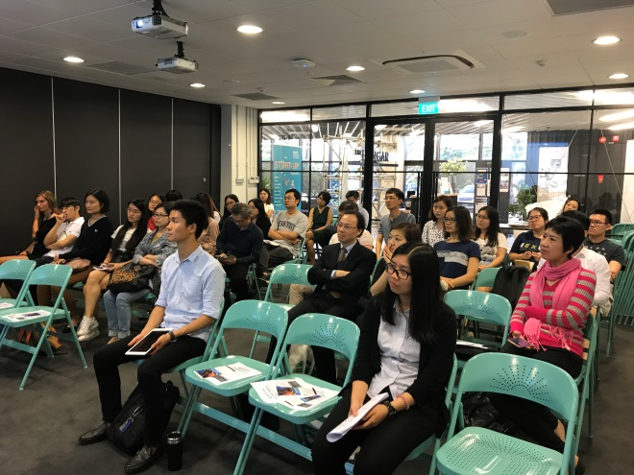
Experience sharing is a way to give back to society what we have learnt. It also brings in a sense of achievement for working professionals. Through inspirational talk, younger generation can avoid mistakes when a similar situation occurs. On behalf of BestTop Consulting and our distinguished partner - NUS Enterprise, our special thanks is dedicated to Frank Koo, People Developer, Head of Asia Business from Linkedin. With his busy schedule, Frank spent an hour between 5:30pm and 6:30pm on 3 July with 30 young talents from BestTop. Sharing with them the importance of talent acquisition and development from his professions, Frank also highlighted how do corporate branding, employer branding and consumer branding have to do with a company’s culture and its influence on talent fulfillment.
“My passion is in helping people make progress in their lives, be they youth planning to fulfill their dreams, professionals looking for career development, colleagues wanting to do better at work or friends thinking of starting a business.” said Frank. With his passion in human resources development and engagement, Frank has turned what he believes into practice. To many fresh graduates and students, it is always a fundamental belief and a positive attitude towards continuous self-improvement that will make your dreams come true. Thanks to Frank again for introducing a larger picture of talent solutions.

